CS 6055- CYBER DEFENSE OVERVIEW
LAB 2 REPORT

Objective:
To find and report all the suspicious findings in the given metasploitable operating system.

Procedure:

Step-1:
The following commands are typed in terminal to connect to the server database
sudo /etc/init.d/postgresql start (to start the database server that is used by metasploit)

Open Armitage
Armitage (to open armitage)

Step 2: We will perform nmap scan to detect the Operating systems. We need to give the IP address details of the OS we want to attack
The IP address details of the metasploitable OS is:

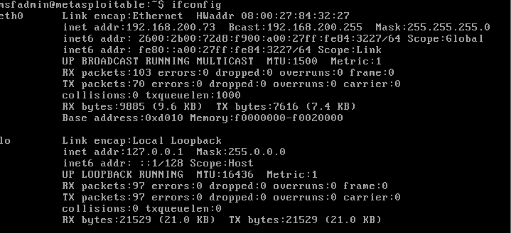

The IP address of Metasploitable is 192.168.200.73
The IP address of kali linux is 192.168.200.46

Step 3: After the nmap is done, the OS will be detected and will be visible in the Armitage.After that we need to select find attacks. Click on the Hail Mary and find attacks on the drop town on the top of the page.
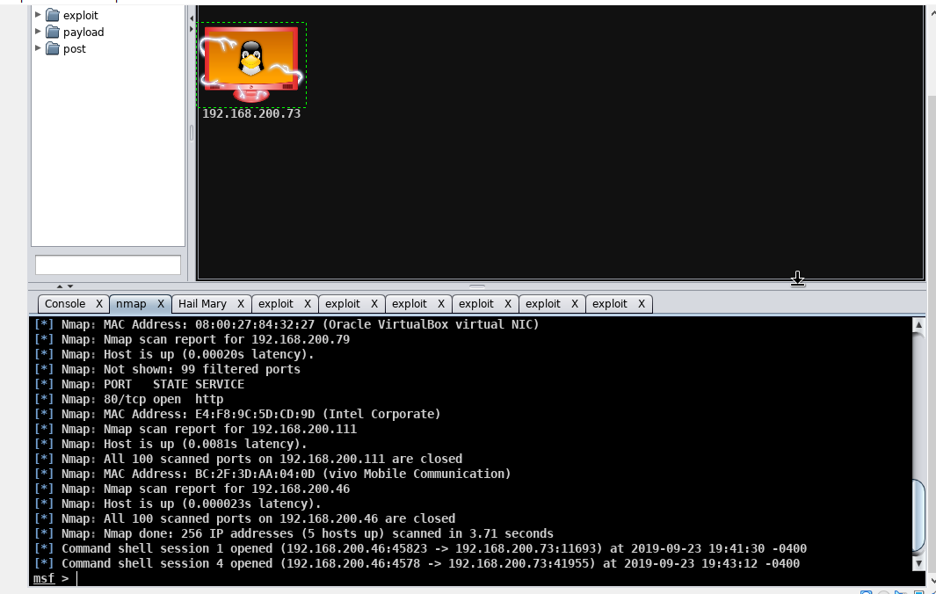

Step 4: The Armitage GUI will find all the attacks. Now when we right click on the attacks we can see all the available attacks. Then from there we need to find all the vulnerabilities.
Step 5: After using Hail Mary, I did not find any vulnerabilities. I found vulnerabilities by trail and error. The list of the exploits I found are:

- exploit/unix/ftp/proftpd_133c_backdoor
- exploit/multi/http/php_cgi_arg_injection
- exploit/unix/irc/unreal_ircd_3281_backdoor
- exploit/freebsd/local/nmap
- exploit/linux/postgres/postgres_payload
- exploit/multi/samba/usermap_scrript
- exploit/webapp/wp_lastpost_exec

Step 6: Check the box “Use a reverse connection”.After launching the attack, we can see the results and the progress in the bottom window.

- The first vulnerability is :exploit/multi/http/php_cgi_arg_injection

After we launch the exploit, we get the window as shown:
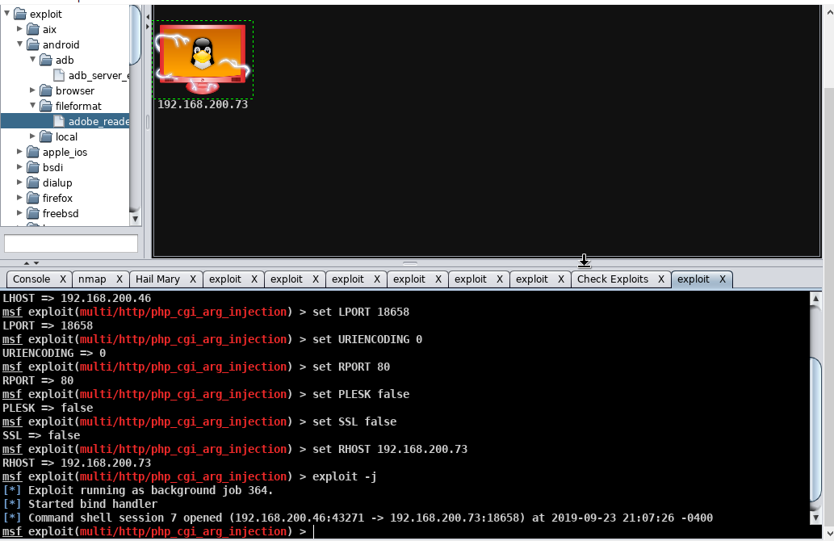

After the launch of the exploit is done command shell session will be opened if the attack is venerable.From the shell, we can exploit the metasploit OS. The shell is opened for this exploit. The screenshot is as below:

The commands like whoami or ls are used to display the host-name and to display the list of items available in the root folder.
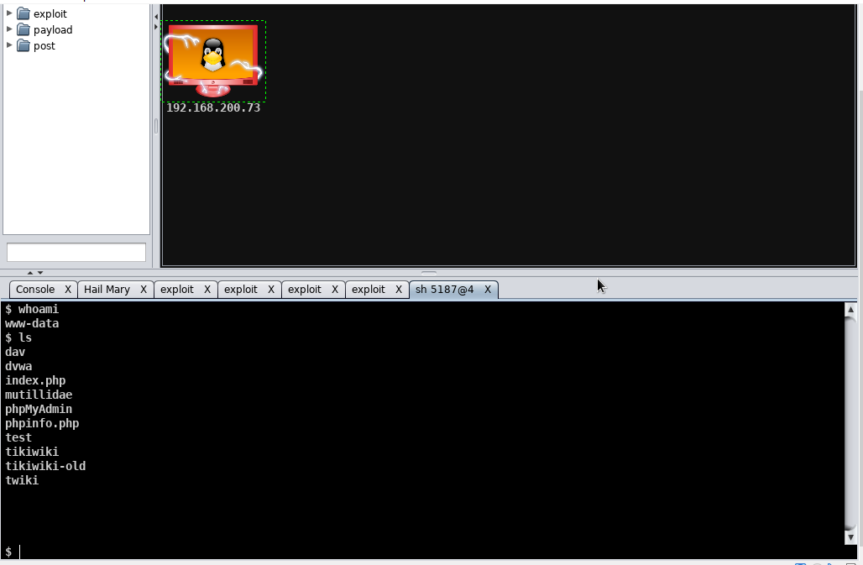

- The second vulnerability is: exploit/unix/ftp/proftpd_133c_backdoor

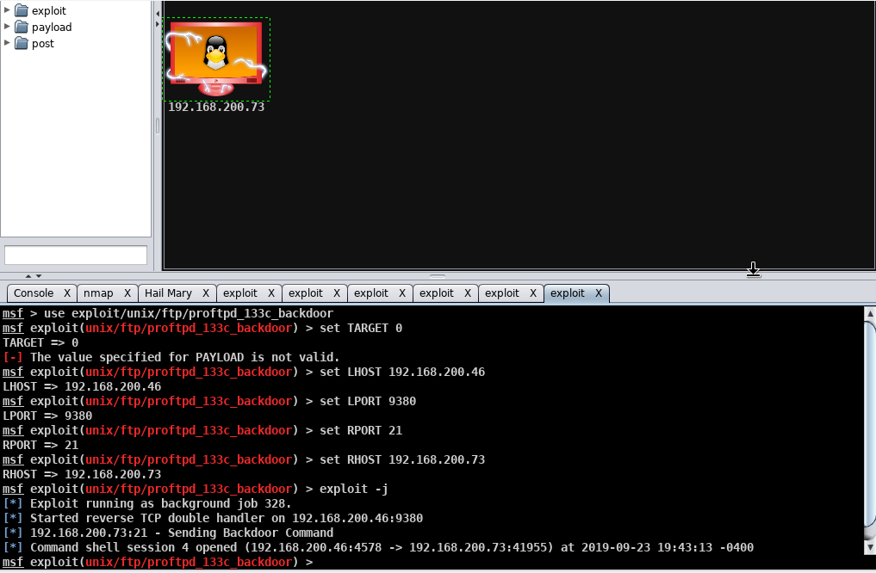

The LPORT and RPORT are displayed along with the IP address. The exploit -j command is used to start the background. Exploit runs in the background job 328. The reverse TCP double handler on 192.168.200.46:9380
A backdoor command is sent via a particular port.

- The third vulnerability is: exploit/unix/irc/unreal_ircd_3281_backdoor
After we launch the exploit, we get the window as shown:

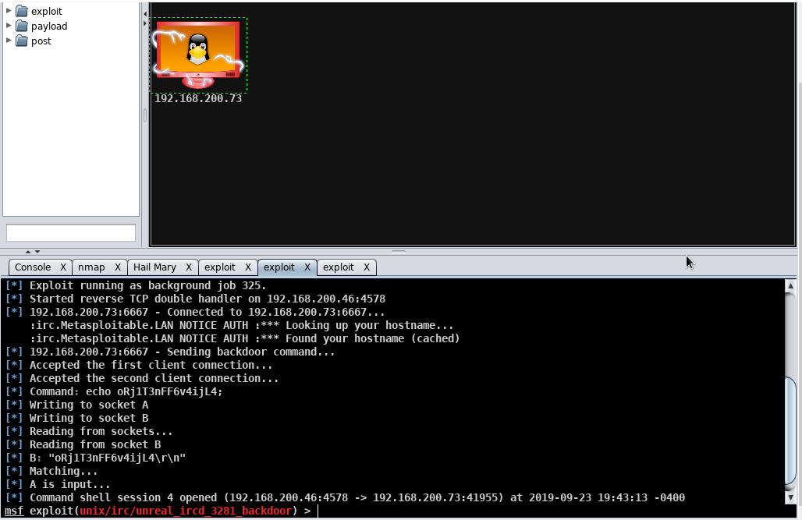
After the launch of the exploit is done command shell session will be opened if the attack is vulnerable.From the shell, we can exploit the metasploit OS. The shell is opened for this exploit. The screenshot is as below:
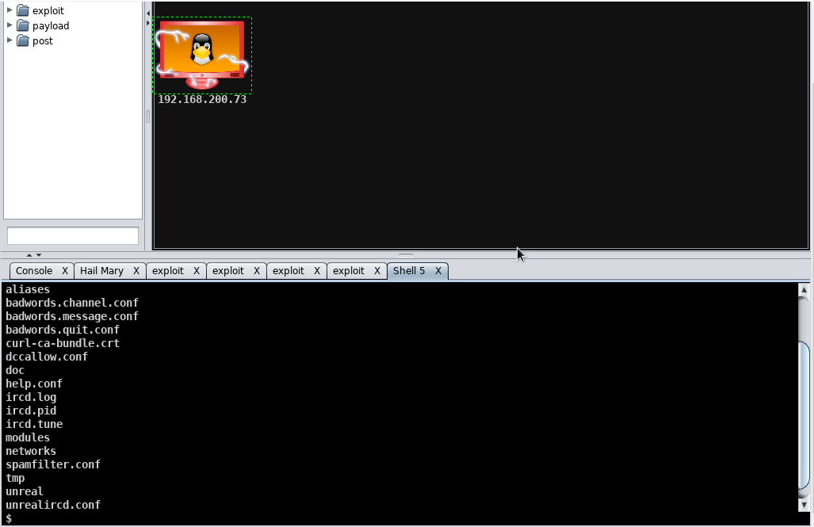
The commands like whoami or ls are used to display the host-name and to display the list of items available in the root folder.

- The fourth vulnerability is : exploit/freebsd/local/nmap
After we launch the exploit, we get the window as shown:

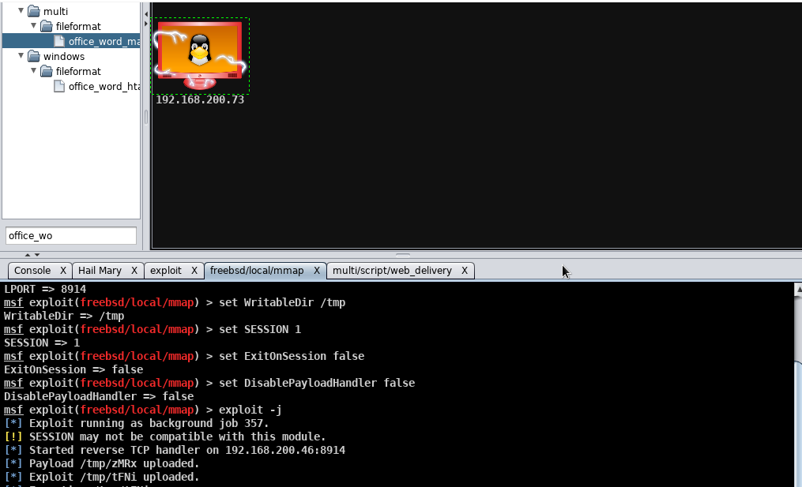

Here, the exploit is running as background job 357. They started reverse TCP handler on 192.168.200.46:8914. Then the payload /tmp/zMRx is uploaded. The exploit /tmp/tFNi is uploaded.

- The fifth vulnerability is : exploit/linux/postgres/postgres_payload
After we launch the exploit, we get the window as shown:

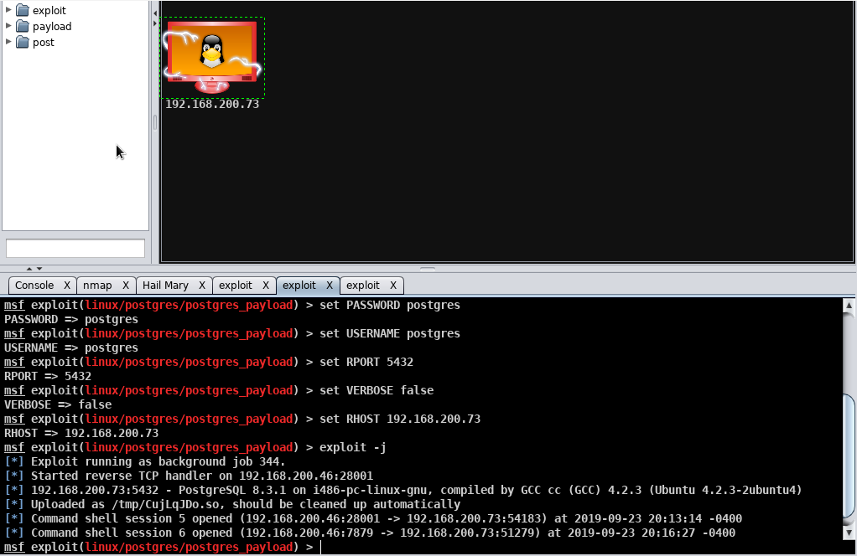

After the launch of the exploit is done command shell session will be opened if the attack is vulnerable.From the shell, we can exploit the metasploit OS. The shell is opened for this exploit. The screenshot is as below:

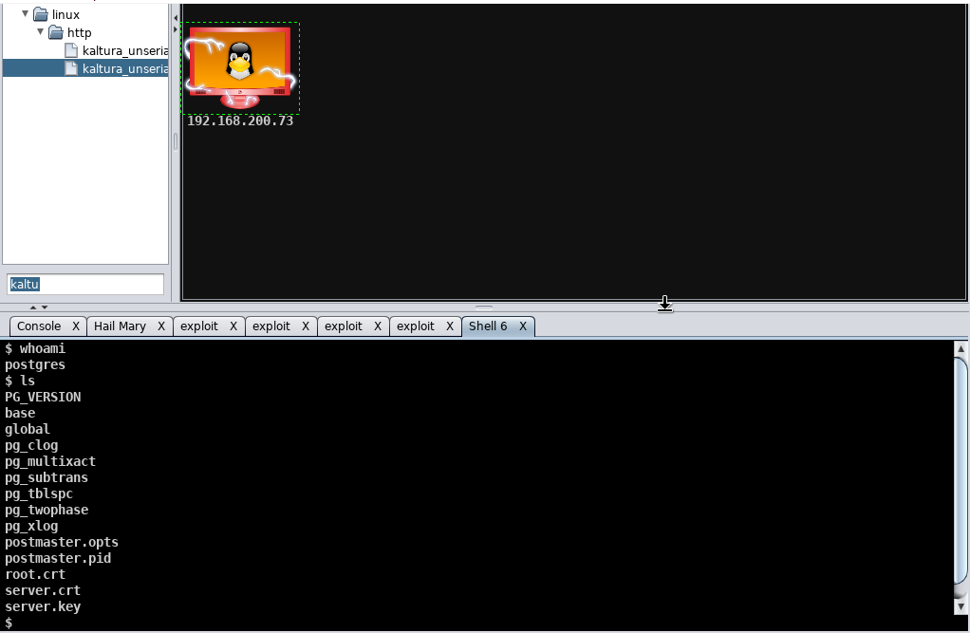

The commands like whoami or ls are used to display the host-name and to display the list of items available in the root folder.

- The sixth vulnerability is:exploit/webapp/wp_lastpost_exec
After we launch the exploit, we get the window as shown:

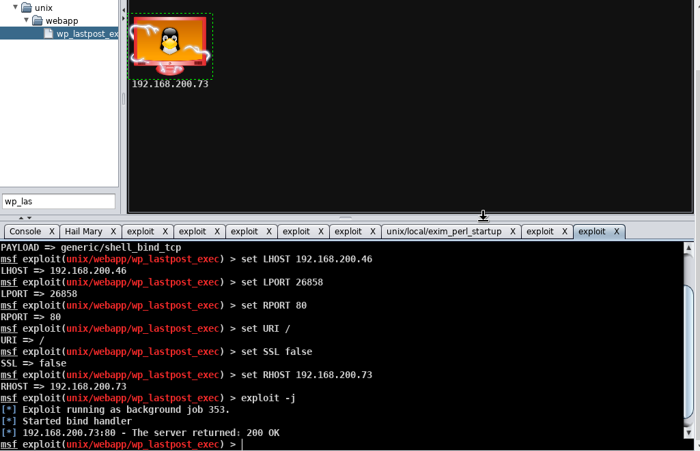
This is the web application which runs the exploit command exploit -j. The exploit runs in the background job 353.The bind handler is started immediately and the server returns an acknowledgement packet as 200 OK.

- The seventh vulnerability is:exploit/multi/samba/usermap_script:
After we launch the exploit, we get the window as shown:

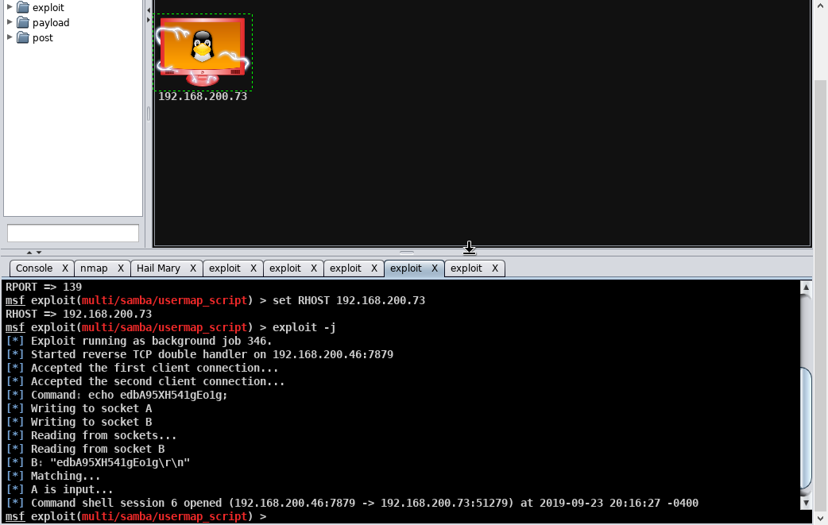
The exploit runs as background job 346. The reverse TCP double handler is started on the IP: 192.168.200.46:7879. The data is written into sockets A and B. The written data is read into the sockets where shell session 6 is opened to interact with it.
The commands like whoami or ls are used to display the host-name and to display the list of items available in the root folder.

